Landing Page:
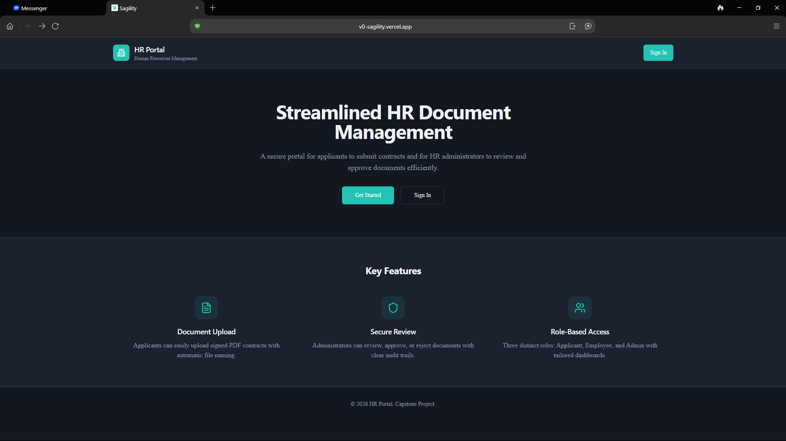
Welcome to the starting page. Here, you can create a new account or log in to your existing account.

Create Account Page:
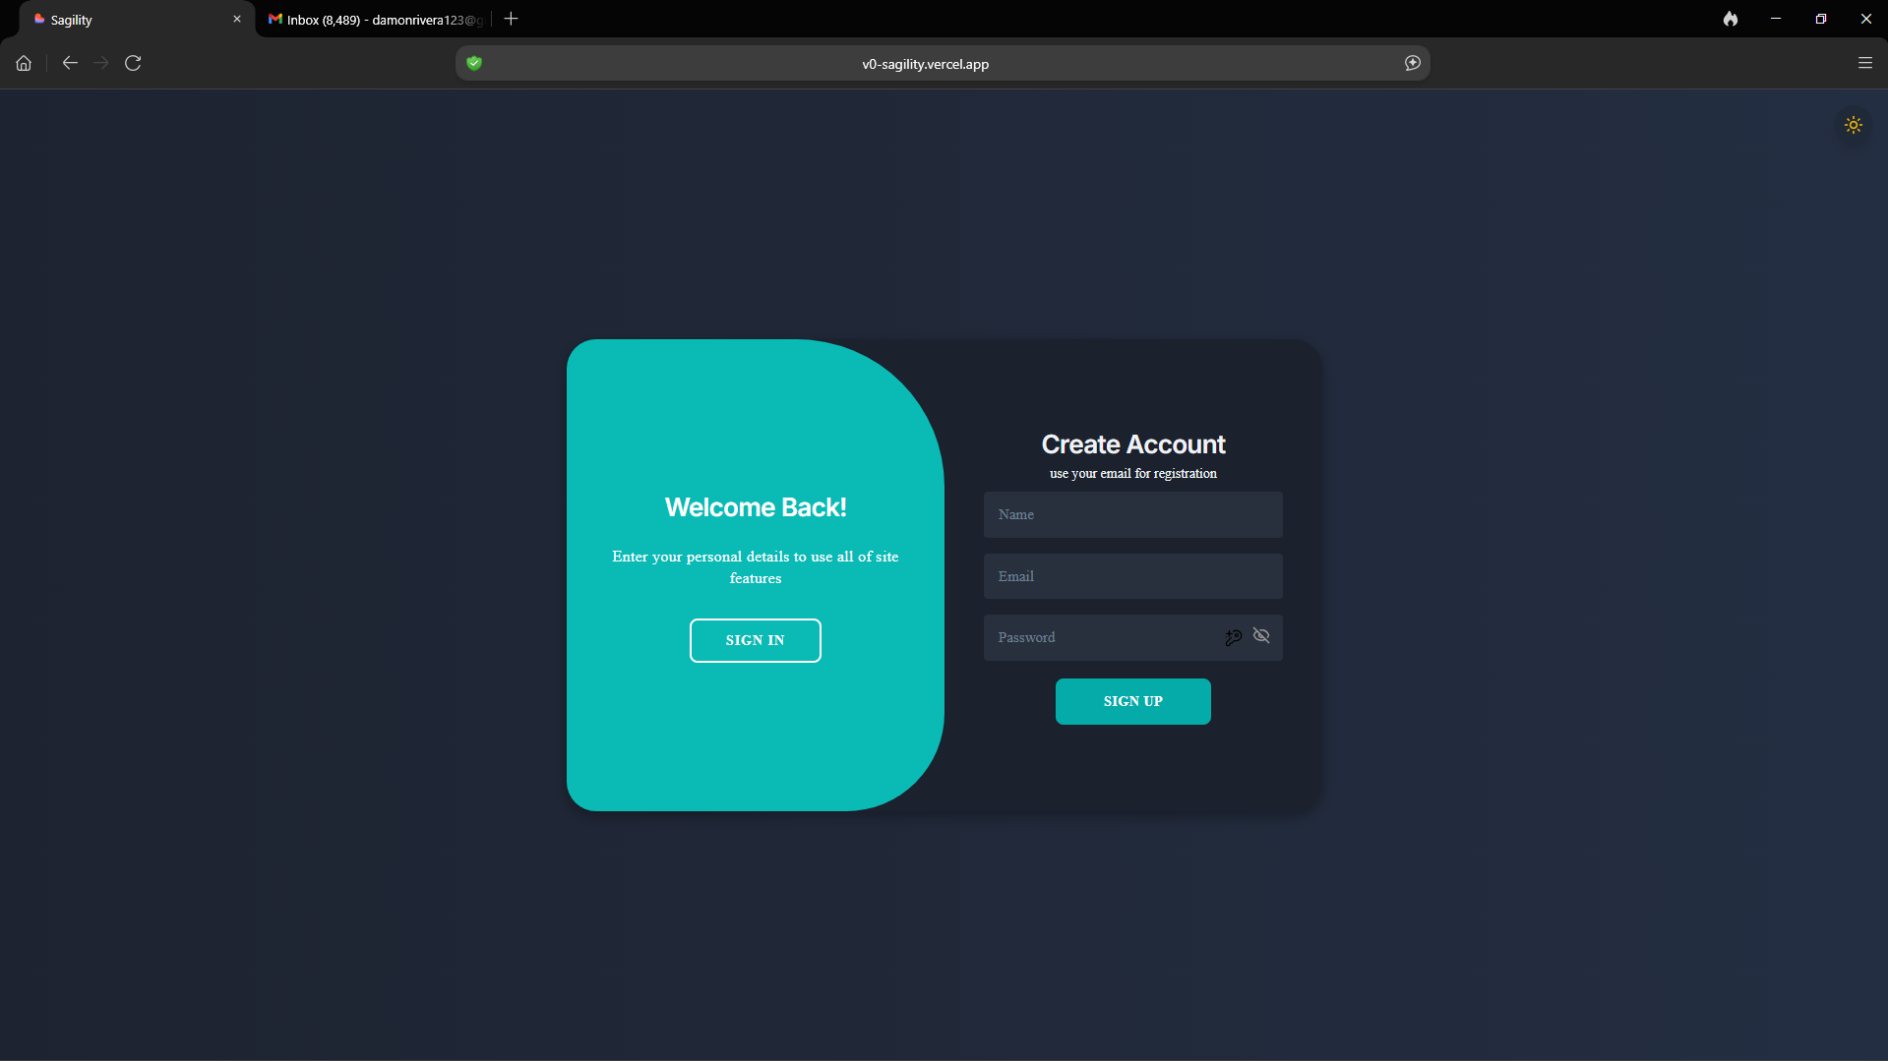
1. Enter your name, email address, and password.
2. Click Sign Up and wait for the confirmation page to appear. (Note: If you already have an account, click Sign In and skip to the Sign In Page section of this manual.)

Confirmation Page:
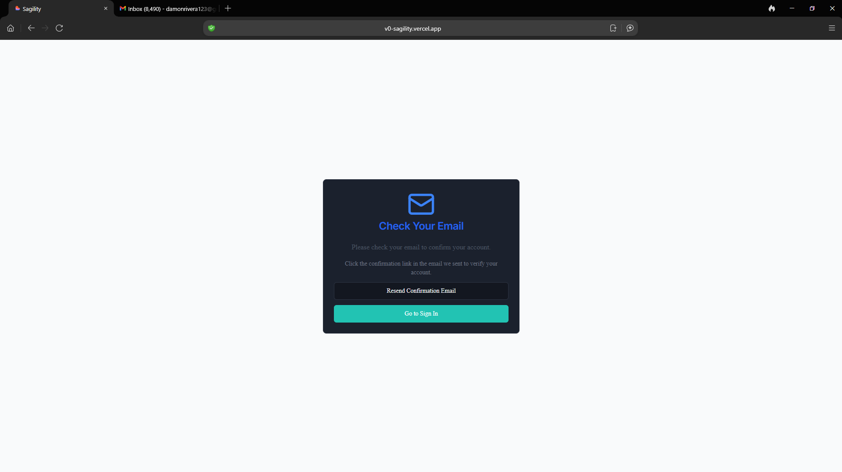
1. Click Sign Up.
2. Open your email inbox and locate the confirmation message. It will look like the example below.

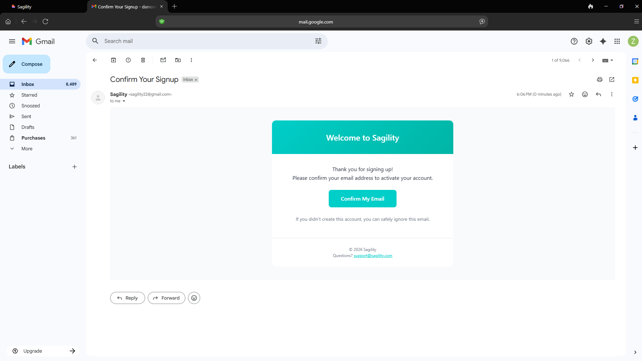
3. Once you have confirmed your email, you will be taken to the following page. 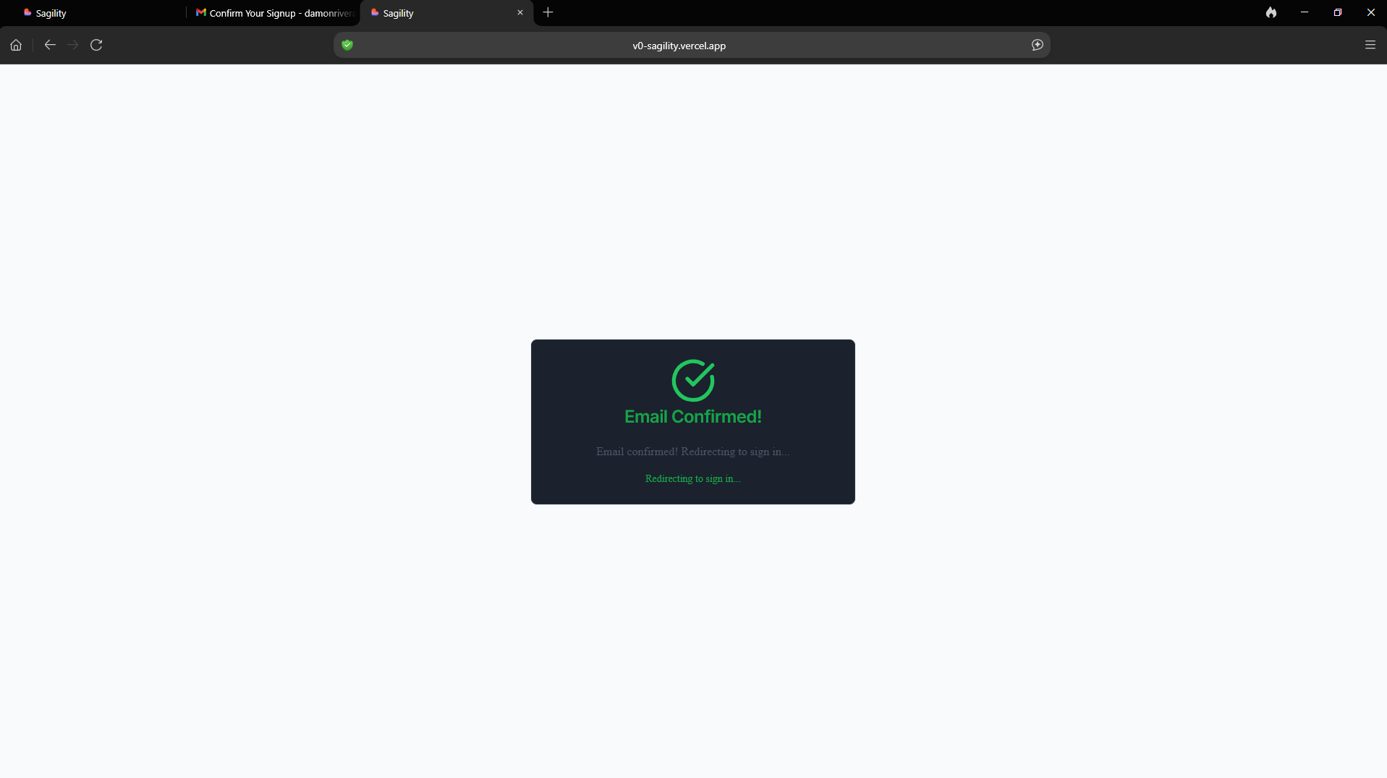

Sign In Page:
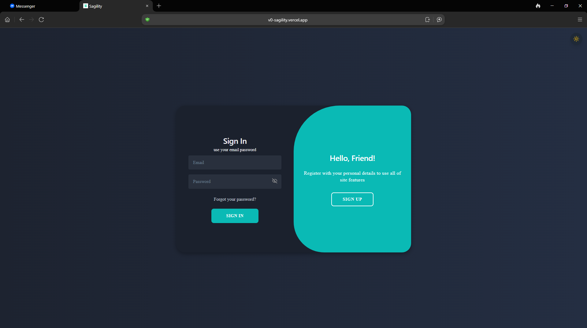
1. Enter your registered email address and password.
2. Click Sign In.

Reset Password:
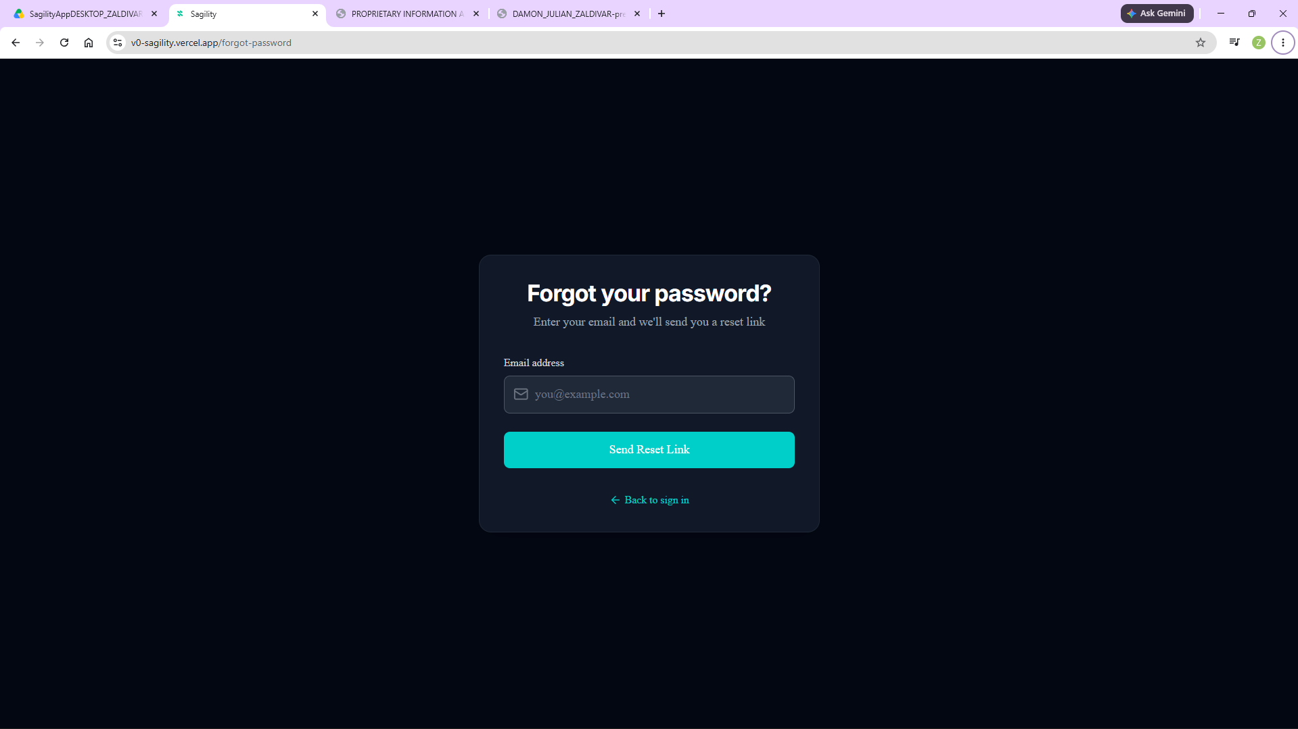
1. Click Forgot your password? on the sign-in screen to open the recovery page.
2. Enter your email address to send a reset link to your inbox.
3. Look for an email matching the example below.

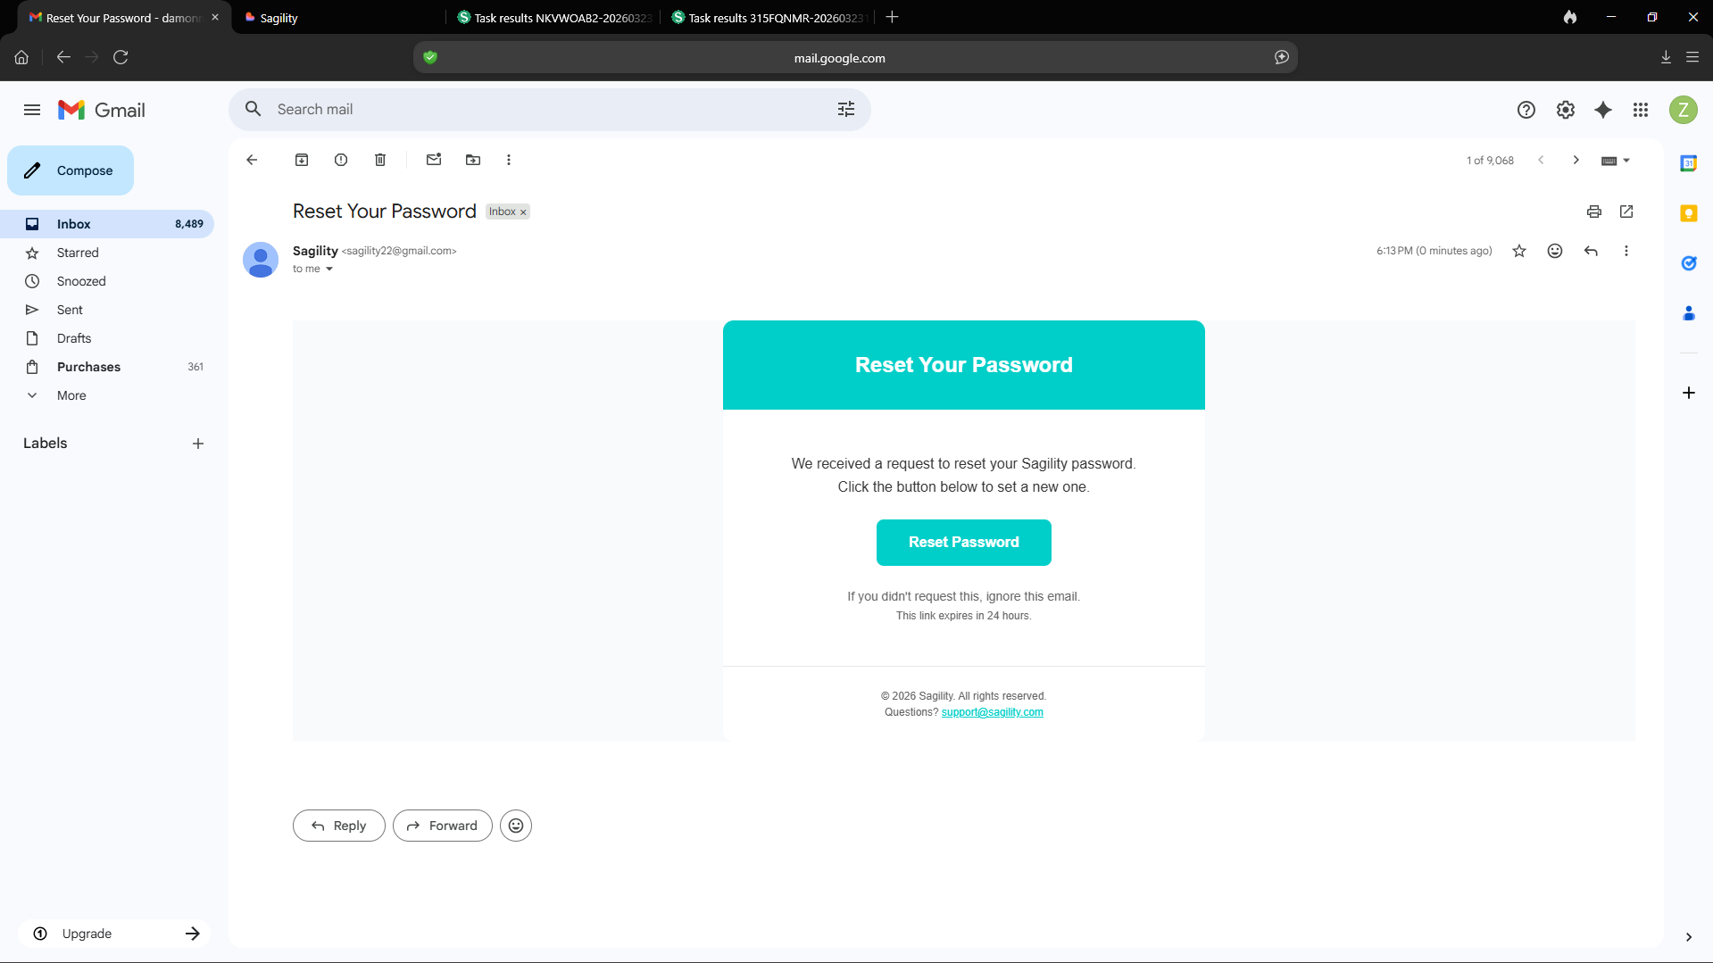
4. Click the 'Reset Password' button, and the following page will appear. 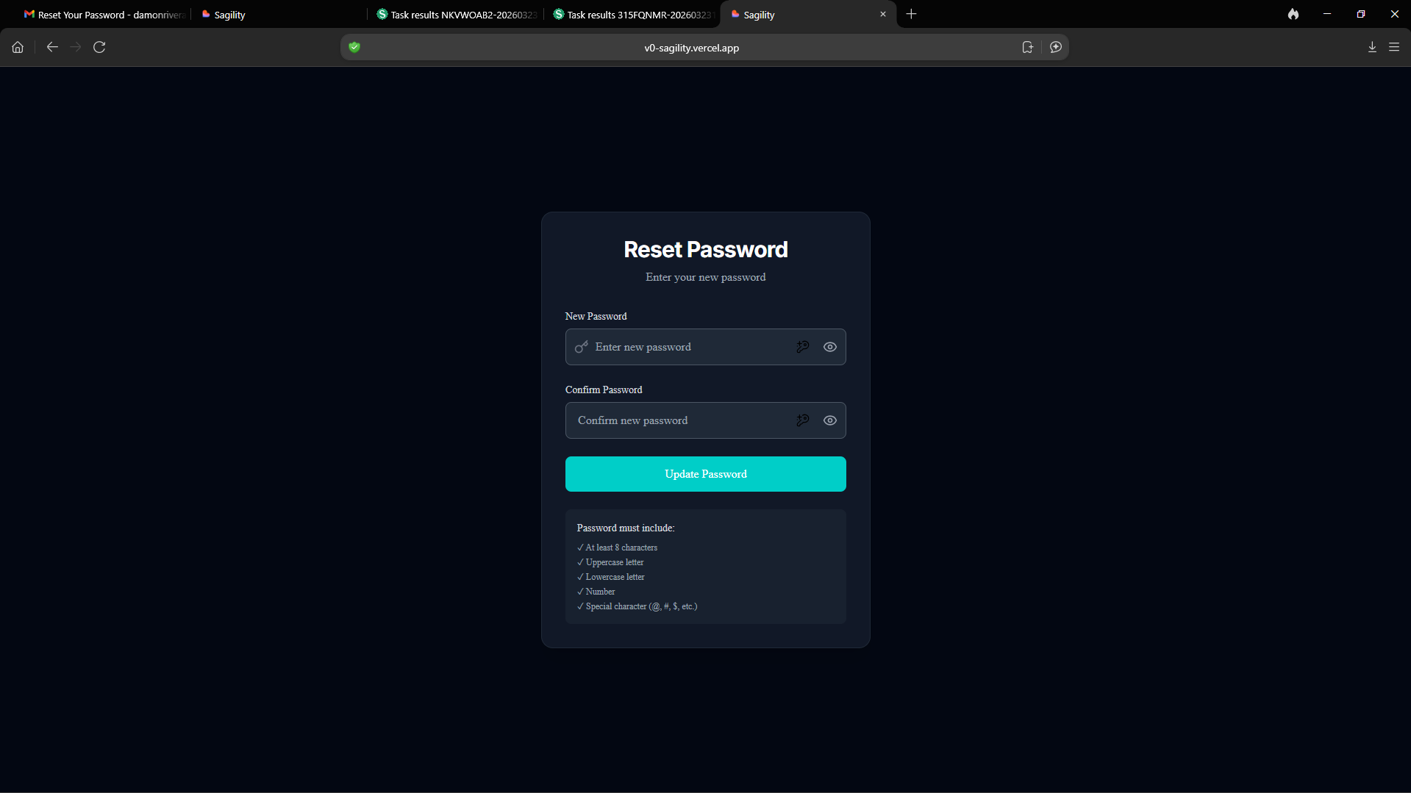
5. Enter your new password and click Update Password.
6. Once your password updates, you will automatically return to the login page.

Applicant Dashboard:
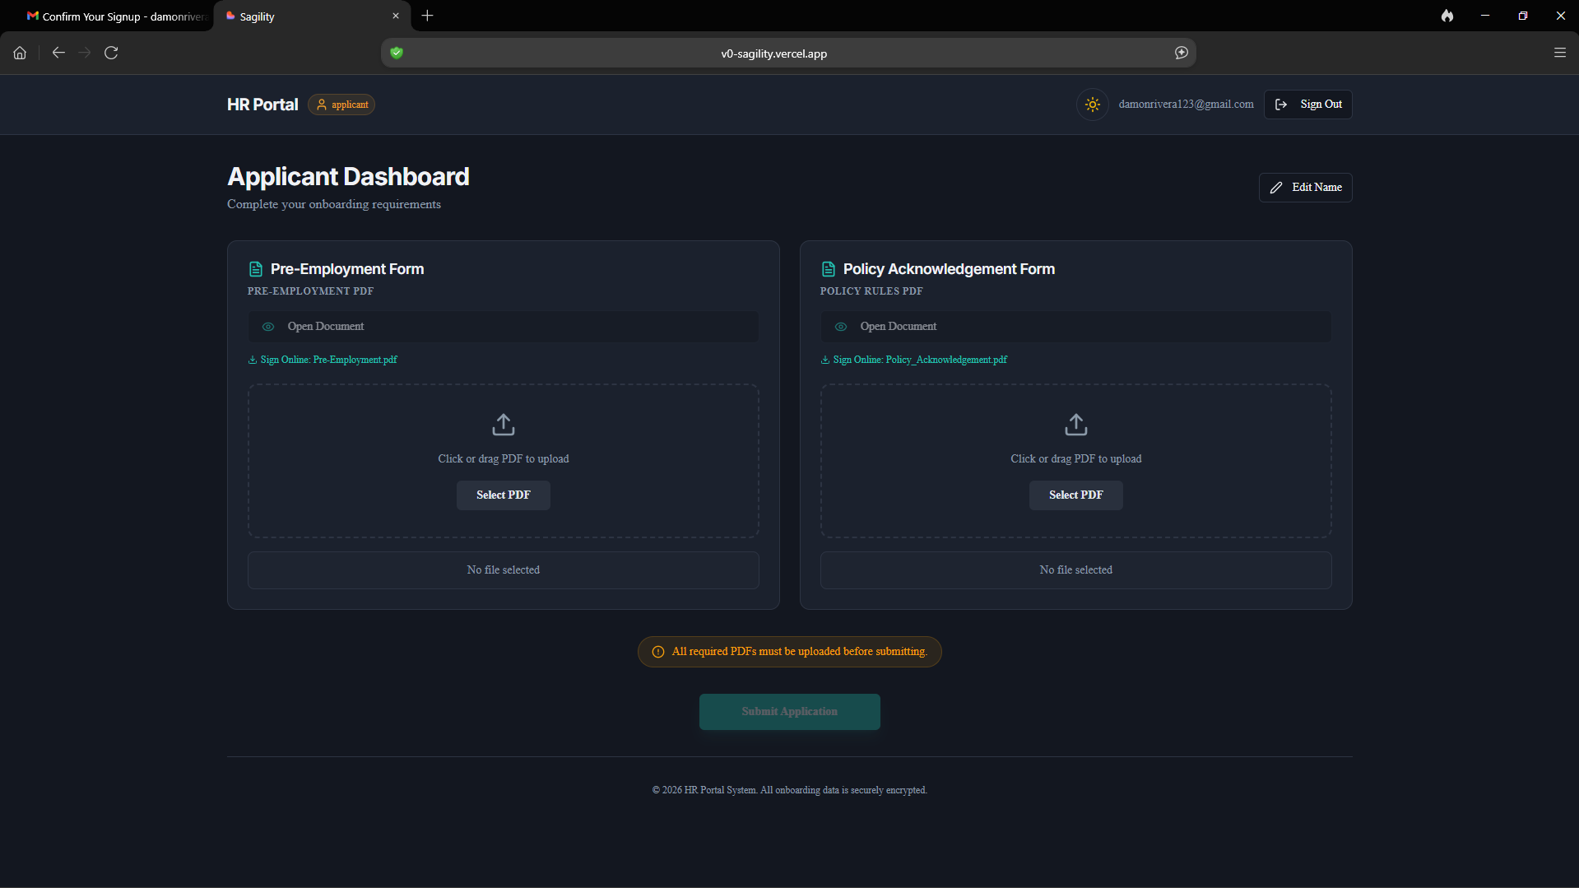
1. Log into your account to access the dashboard.
2. Click the Open Document buttons to access and fill out the Pre-Employment Form and Policy Acknowledgement Form.
3. Alternatively, if you already have completed copies, drag and drop your PDF files into the upload boxes under each form section.

Pre-Employment Form Page:
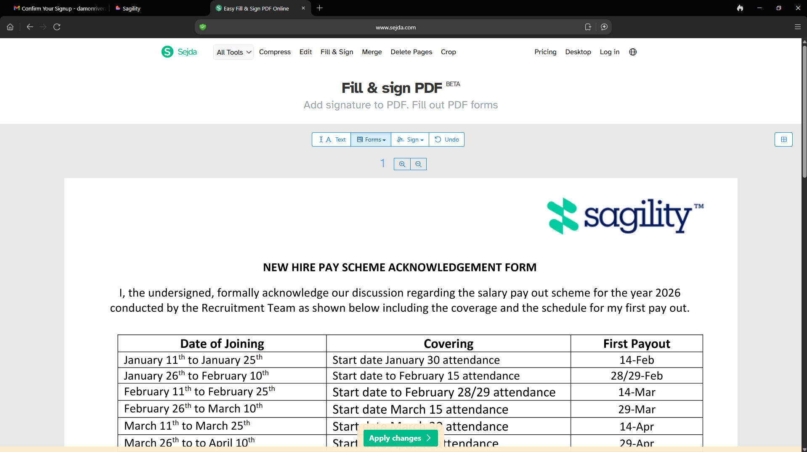
1. In the Applicant Dashboard, locate the Pre-Employment Form and click Open Document.
2. Review the details for your Date of Joining, Covering, and First Payout.
3. Scroll to the bottom of the page.
4. Enter your name, the current date, and your signature above your name.
5. Click Apply Changes to view the following pages.
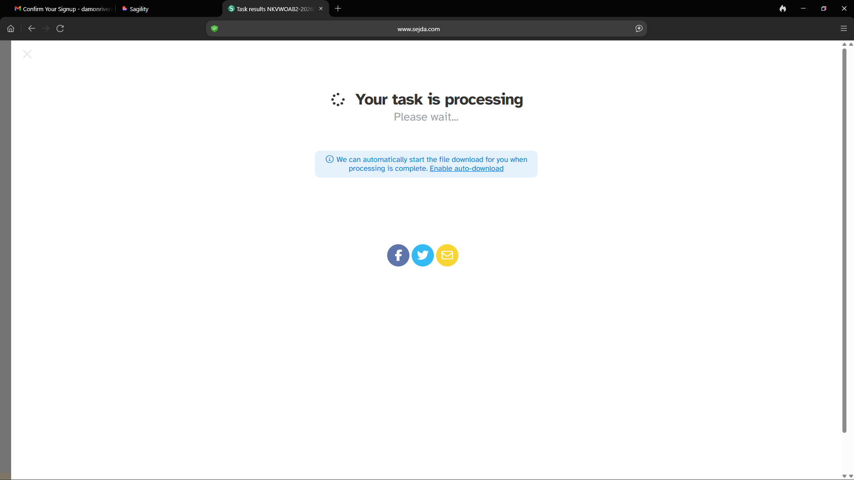
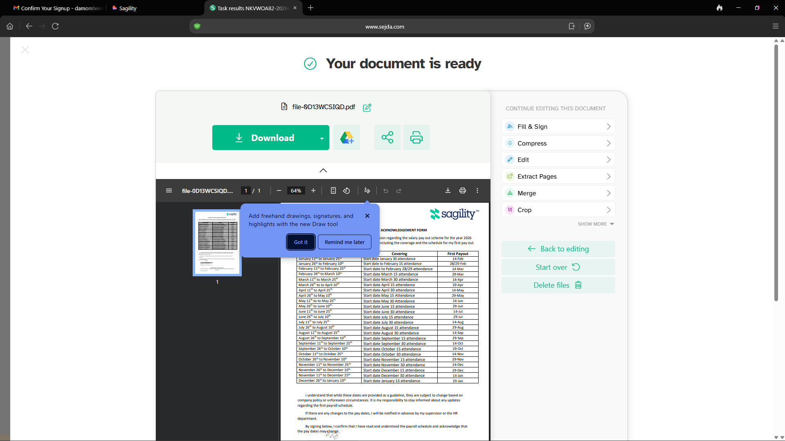
1. When the second page appears, click Download and wait for the file to save.
2. Open your device's Downloads folder.
3. Drag and drop the PDF into the upload box under Pre-Employment Form on the Applicant Dashboard.

Policy Acknowledgement Form Page:
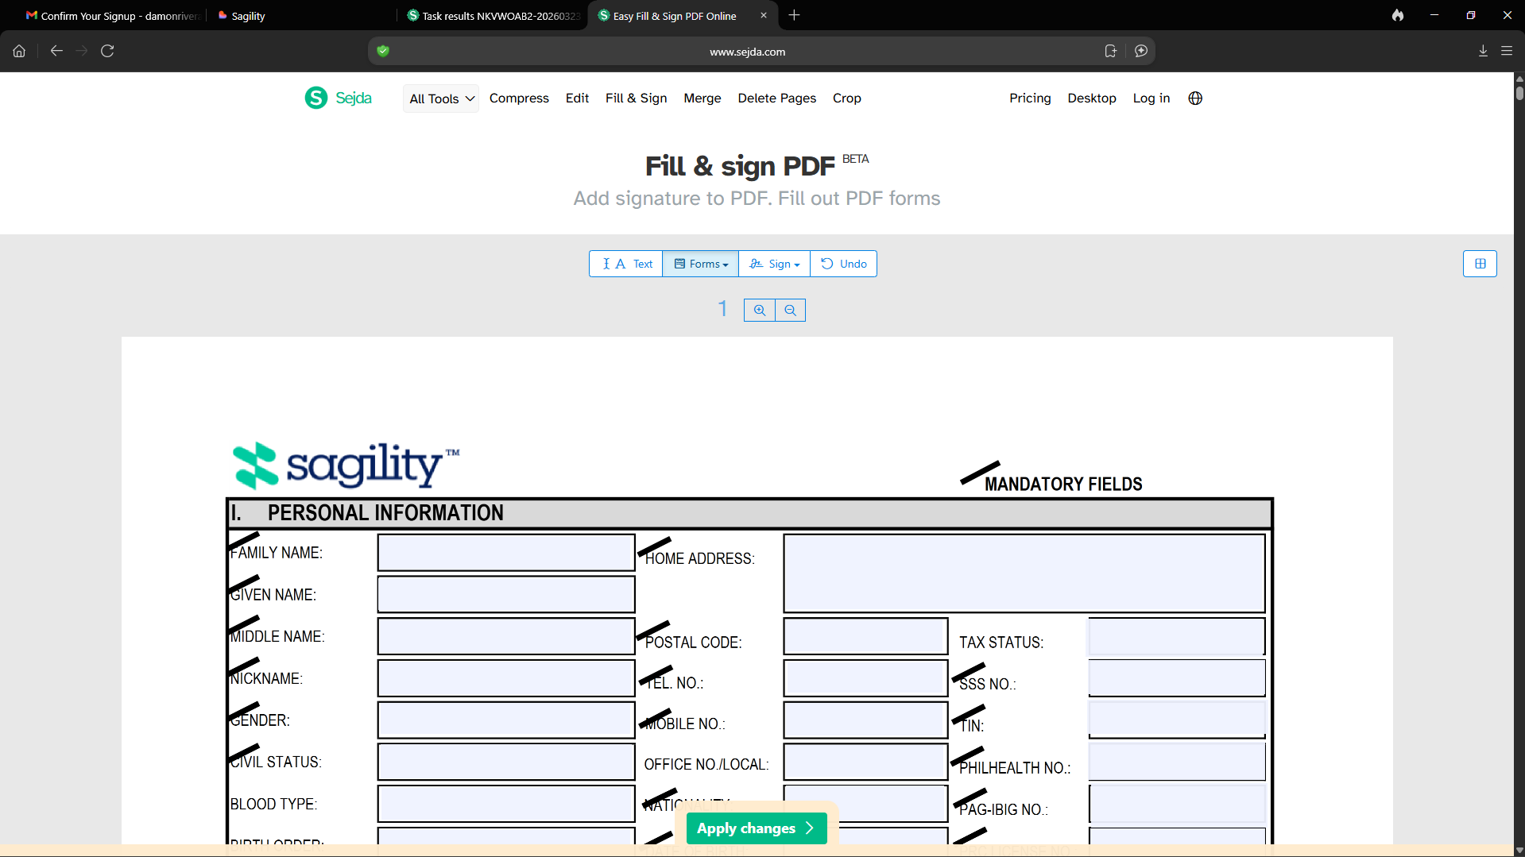
1. Go to the Applicant Dashboard and click Open Document under Policy Acknowledgement Form.
2. Fill out the required personal, parent, and spouse details. (Note: Fields marked with a slanted line are mandatory.)
3. Scroll to the Authorization Form at the bottom and enter your full name, degree/course, college/university, signature, printed name, and date.
4. Click Apply Changes. Once the document loads, click Download.
5. Open your device's Downloads folder, then drag and drop the file into the upload box under Policy Acknowledgement Form on your dashboard.

Submitting PDF Forms: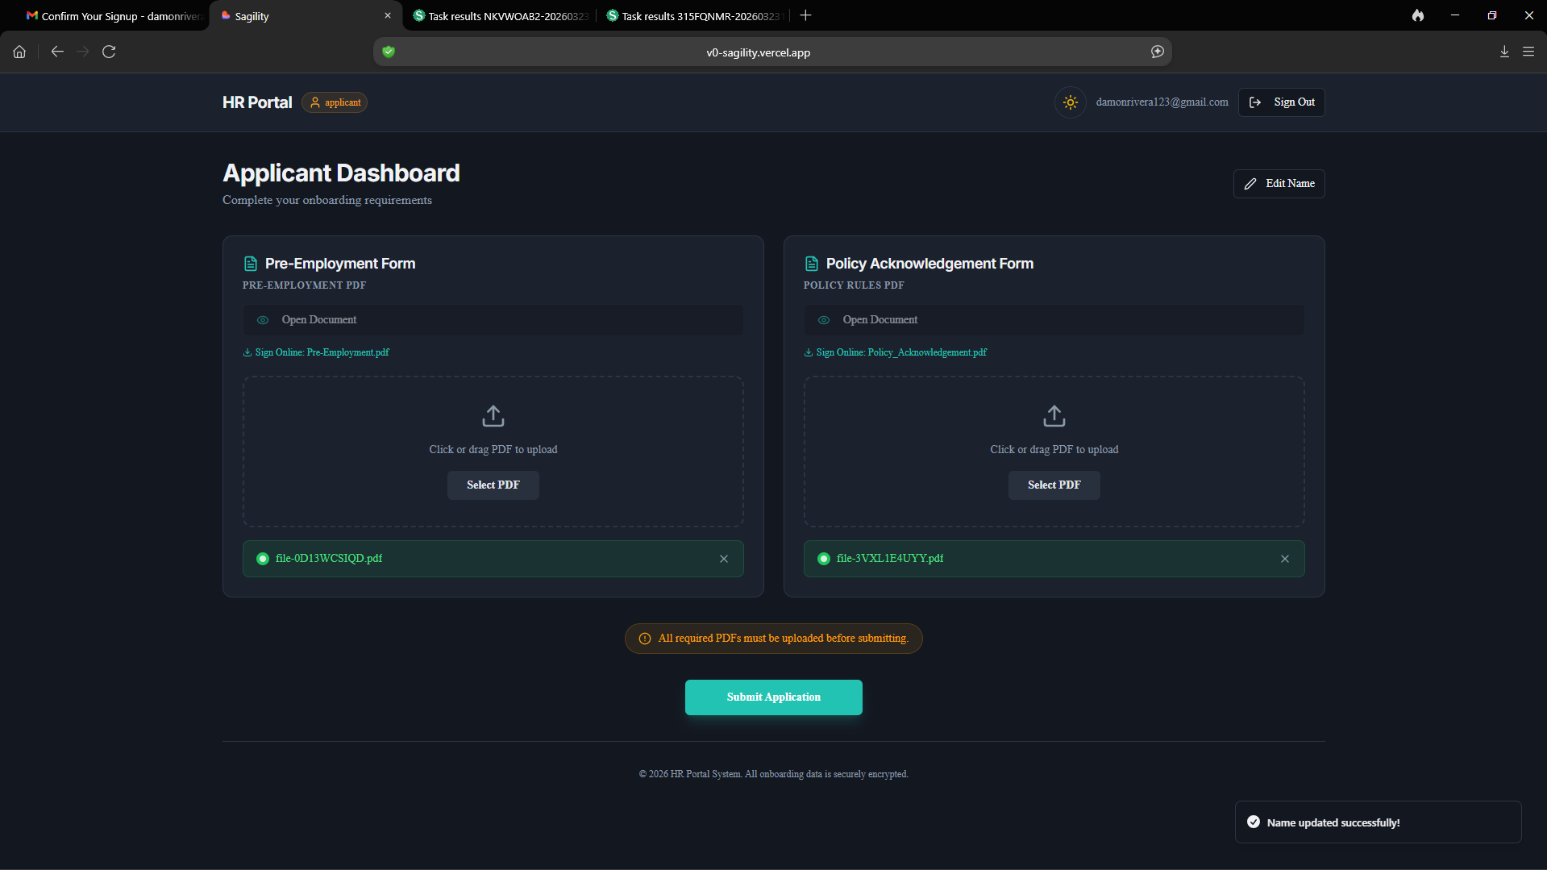
After uploading both completed forms, click 'Submit Application' to send them to the Admin for review. The Admin will process your submission and take one of three actions:
- Approve: If no issues are found.
- Return for Revision: If corrections are needed.
- Reject: If your application does not meet the requirements

